Terraform challenge-03

Goal of the Exercise
The goal of this exercise is to test your understanding of a Cloud Compute deployment with Terraform.
You are tasked with creating a codebase for a microservice deployment on a cloud environment, using Terraform. Since our focus is not the application itself, the service will be a simple web server that returns a static page.
Requirements
Service Details
- The service will be a simple web server that returns a static page.
- You can useapache2ornginxto serve a simple HTML file.
- The service should becontainerizedand stored in aDocker registry.
- The service should be deployed on asingle VM instanceas a docker container.
- The image should be pulled from the registry specified earlier.
- The service shouldnotbe accessible from the internet but only through aLoad Balancer, except for SSH access from specific IP addresses.
Deliverables
You are to provide the following as part of your solution:
- Dockerfileto build the image.
- Terraform codebaseto deploy the following:
  - Docker registry
  - VPC and all required networking resources
  - EC2 instance
  - Load Balancer
Notes
- Since a CI/CD pipeline is not part of this exercise, we will work around that with the help of Terraform.
- To push the image to the Docker registry,build the image locallybefore running the Terraform code.
- Once the image registry is created, use Terraform topush the local imageto the registry.
- Similarly, use Terraform topull the imagefrom the registry and run it on the VM instance once it is created.
- For SSH access:
  - Use a locally created key.
  - Add it to the cloud provider key storage.
  - Attach it to the instance.
- UseTerraform best practicesfor file structure and code organization.
  - Use variables, locals, modules, etc. when appropriate.
- Include alltfvars, scripts, and other helper files used to deploy the application.
- You may use any cloud provider of your choosing, althoughAWS is preferred.
- Use afree tier accountor atrial accountto deploy the resources.

1. Title Page
Terraform Microservice Deployment on AWS
Include:
- Name: Syed Sarfaraz
- Technology: AWS + Terraform + Docker + ECR + EC2 + ALB
- Deployment Region: us-east-1

2. Objective
Write briefly:
The objective of this exercise is to deploy a containerized static web microservice on AWS using Terraform. The application is stored in Amazon ECR and deployed as a Docker container on a private EC2 instance. The application is accessed through an Application Load Balancer, while SSH access is restricted to the configured public IP address.

3. Prerequisites
List:
- AWS account
- AWS CLI
- Terraform
- Docker
- SSH key
- VS Code
- AWS credentials configured
- Dockerfile/application files

4. Project Structure
Show your project structure.
For example:
microservice-project/
│
├── app/
│ ├── Dockerfile
│ └── index.html
│
├── scripts/
│ └── userdata.sh
│
├── main.tf
├── variables.tf
├── terraform.tfvars
└── outputs.tf
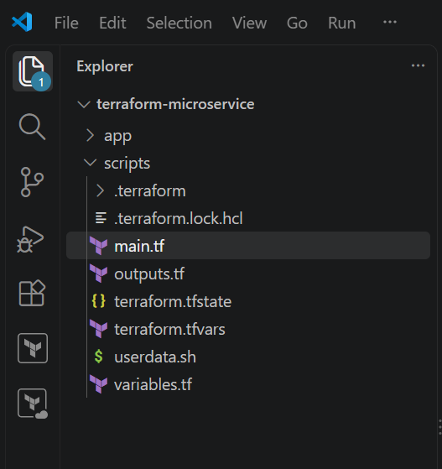

5. Generate SSH Key
Before Terraform deployment, generate the SSH key:
ssh-keygen -t rsa -b 4096 -f ~/.ssh/id_rsa
Your Terraform configuration uses the generated public key through public_key_path.
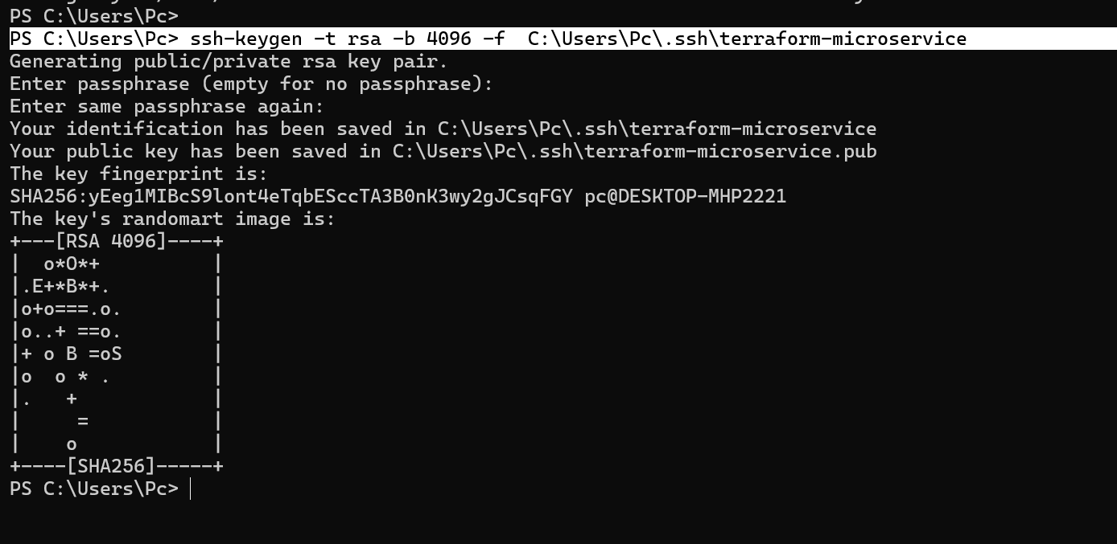

6. Create Docker Application
Explain that the application is a simple static web page served using Nginx/Apache.
Show:
app/
├── Dockerfile
└── index.html
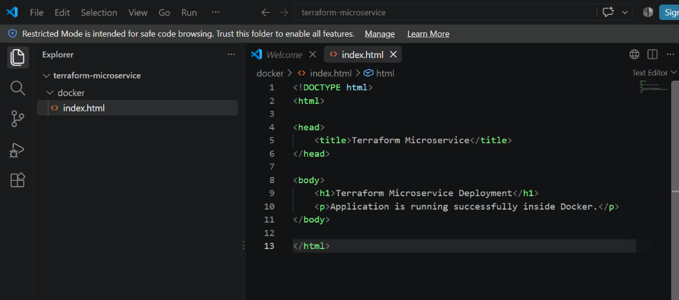
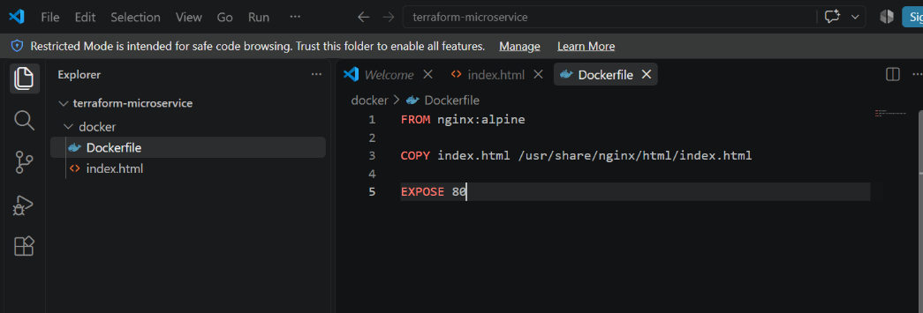
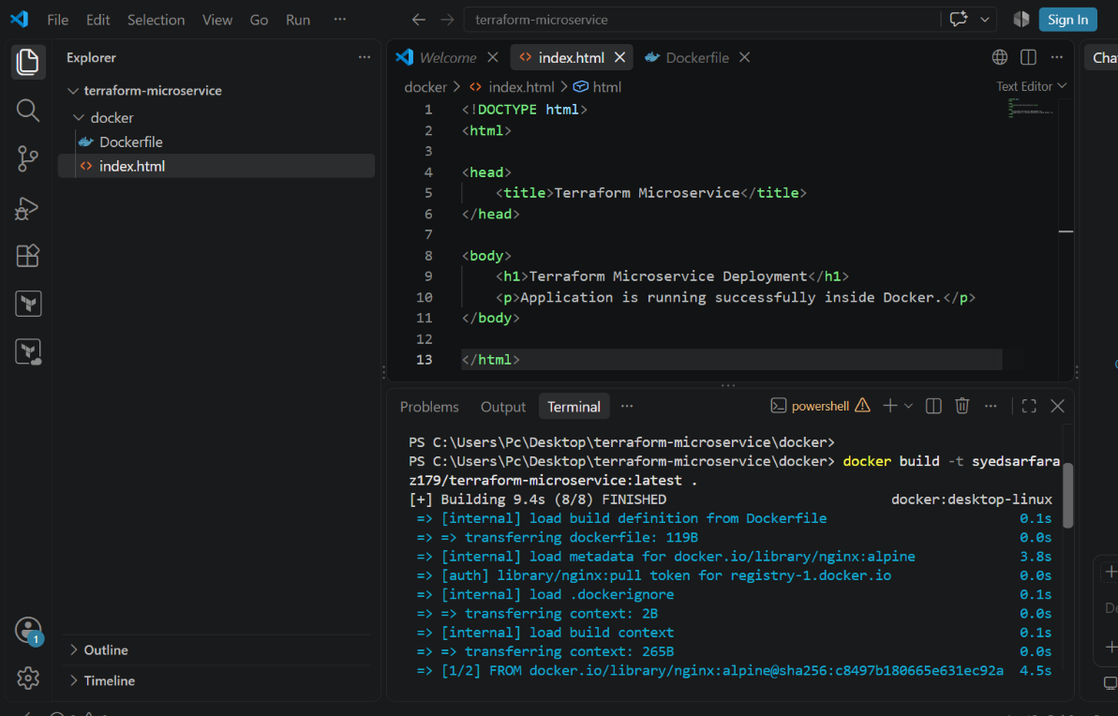
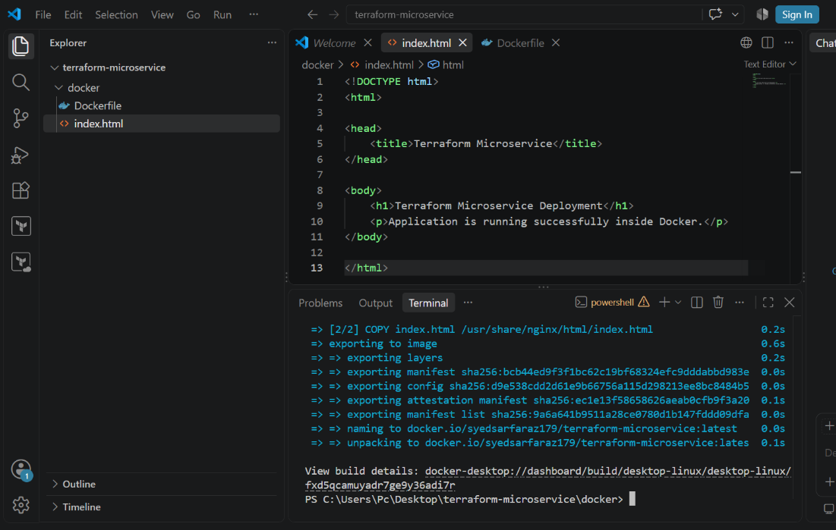
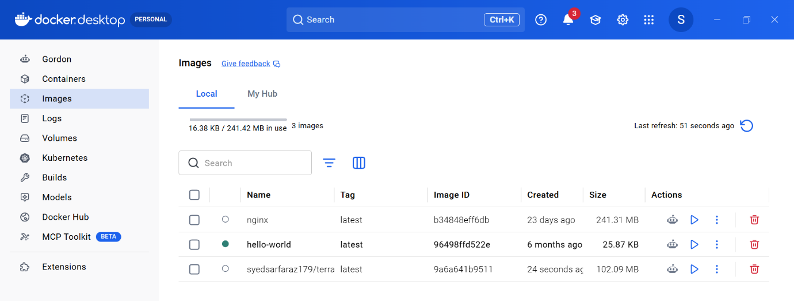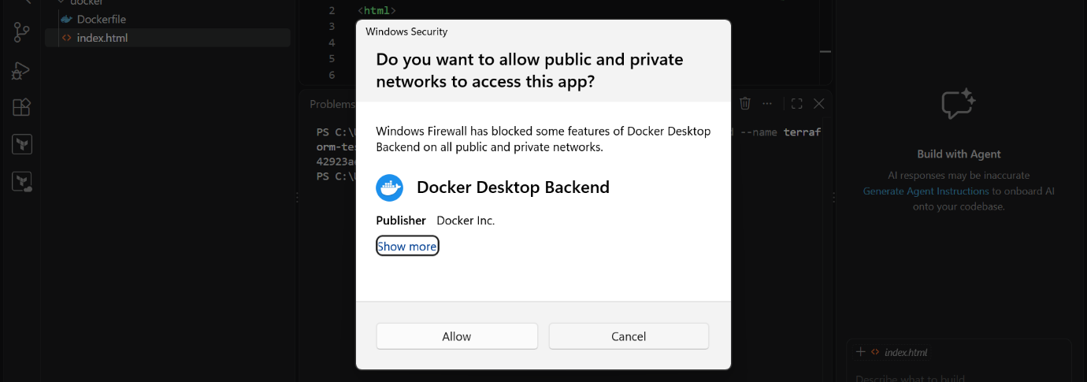
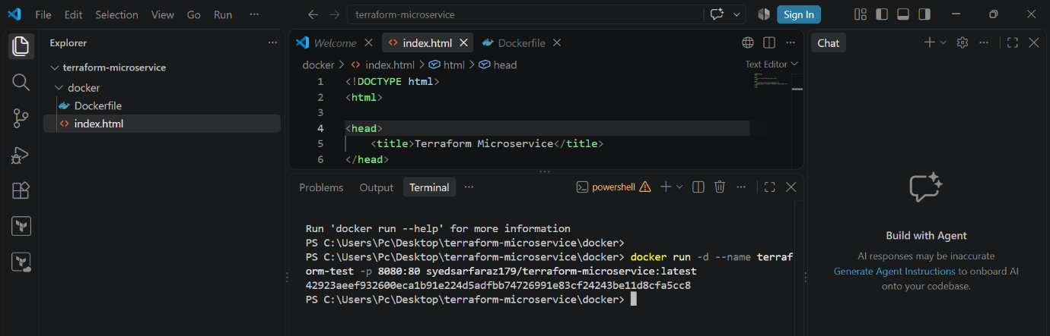

7. Terraform Provider Configuration
Explain that Terraform uses:
- AWS provider
- Docker provider
The configuration specifies AWS and Docker providers.

main.tf
terraform {
required_providers {
aws = {
source = "hashicorp/aws"
version = "~> 5.0"
}
docker = {
source = "kreuzwerker/docker"
version = "~> 3.0"
}
}
}

provider "aws" {
region = var.aws_region
}

# -----------------------------------------------------------------------------
# 1. NETWORKING (VPC, Subnets, IGW, NAT Gateway, Route Tables)
# -----------------------------------------------------------------------------
data "aws_availability_zones" "available" {
state = "available"
}

resource "aws_vpc" "main" {
cidr_block = "10.0.0.0/16"
enable_dns_hostnames = true
tags = { Name = "microservice-vpc" }
}

resource "aws_internet_gateway" "igw" {
vpc_id = aws_vpc.main.id
tags = { Name = "main-igw" }
}

# Public Subnets (for ALB)
resource "aws_subnet" "public_1" {
vpc_id = aws_vpc.main.id
cidr_block = "10.0.1.0/24"
availability_zone = data.aws_availability_zones.available.names[0]
tags = { Name = "public-subnet-1" }
}

resource "aws_subnet" "public_2" {
vpc_id = aws_vpc.main.id
cidr_block = "10.0.2.0/24"
availability_zone = data.aws_availability_zones.available.names[1]
tags = { Name = "public-subnet-2" }
}

# Private Subnet (for EC2)
resource "aws_subnet" "private_1" {
vpc_id = aws_vpc.main.id
cidr_block = "10.0.10.0/24"
availability_zone = data.aws_availability_zones.available.names[0]
tags = { Name = "private-subnet-1" }
}

# Elastic IP for NAT Gateway
resource "aws_eip" "nat" {
domain = "vpc"
depends_on = [aws_internet_gateway.igw]
}

# NAT Gateway to let private EC2 pull from ECR
resource "aws_nat_gateway" "nat" {
allocation_id = aws_eip.nat.id
subnet_id = aws_subnet.public_1.id
tags = { Name = "main-nat-gateway" }
}

# Routing
resource "aws_route_table" "public" {
vpc_id = aws_vpc.main.id
route {
cidr_block = "0.0.0.0/0"
gateway_id = aws_internet_gateway.igw.id
}
}

resource "aws_route_table" "private" {
vpc_id = aws_vpc.main.id
route {
cidr_block = "0.0.0.0/0"
nat_gateway_id = aws_nat_gateway.nat.id
}
}

resource "aws_route_table_association" "public_1" {
subnet_id = aws_subnet.public_1.id
route_table_id = aws_route_table.public.id
}

resource "aws_route_table_association" "public_2" {
subnet_id = aws_subnet.public_2.id
route_table_id = aws_route_table.public.id
}

resource "aws_route_table_association" "private_1" {
subnet_id = aws_subnet.private_1.id
route_table_id = aws_route_table.private.id
}

# -----------------------------------------------------------------------------
# 2. DOCKER REGISTRY (AWS ECR) & LOCAL IMAGE BUILD/PUSH
# -----------------------------------------------------------------------------
resource "aws_ecr_repository" "app_repo" {
name = "microservice-app"
image_tag_mutability = "MUTABLE"
force_delete = true
}

data "aws_ecr_authorization_token" "token" {}

provider "docker" {
registry_auth {
address = data.aws_ecr_authorization_token.token.proxy_endpoint
username = data.aws_ecr_authorization_token.token.user_name
password = data.aws_ecr_authorization_token.token.password
}
}

resource "docker_image" "local_build" {
name = "${aws_ecr_repository.app_repo.repository_url}:latest"
build {
# Points to the actual 'app/' folder relative to the 'scripts/' execution path
context = "${path.module}/../app" #In Your case it should be index.html page with dockerfile
dockerfile = "Dockerfile"
}
}

resource "docker_registry_image" "push_to_ecr" {
name = docker_image.local_build.name
keep_remotely = true
}

# -----------------------------------------------------------------------------
# 3. SECURITY GROUPS
# -----------------------------------------------------------------------------
resource "aws_security_group" "alb_sg" {
name = "alb-security-group"
vpc_id = aws_vpc.main.id
description = "Allow public HTTP traffic"

ingress {
from_port = 80
to_port = 80
protocol = "tcp"
cidr_blocks = ["0.0.0.0/0"]
}

egress {
from_port = 0
to_port = 0
protocol = "-1"
cidr_blocks = ["0.0.0.0/0"]
}
}

resource "aws_security_group" "ec2_sg" {
name = "ec2-security-group"
vpc_id = aws_vpc.main.id
description = "Isolate instance traffic"

# HTTP strictly from ALB
ingress {
from_port = 80
to_port = 80
protocol = "tcp"
security_groups = [aws_security_group.alb_sg.id]
}

# SSH strictly from your designated IP
ingress {
from_port = 22
to_port = 22
protocol = "tcp"
cidr_blocks = [var.my_ip]
}

egress {
from_port = 0
to_port = 0
protocol = "-1"
cidr_blocks = ["0.0.0.0/0"]
}
}

# -----------------------------------------------------------------------------
# 4. LOAD BALANCER (ALB)
# -----------------------------------------------------------------------------
resource "aws_lb" "external_alb" {
name = "microservice-alb"
internal = false
load_balancer_type = "application"
security_groups = [aws_security_group.alb_sg.id]
subnets = [aws_subnet.public_1.id, aws_subnet.public_2.id]
}

resource "aws_lb_target_group" "tg" {
name = "microservice-tg"
port = 80
protocol = "HTTP"
vpc_id = aws_vpc.main.id
target_type = "instance"

health_check {
path = "/"
port = "80"
protocol = "HTTP"
interval = 30
timeout = 5
healthy_threshold = 2
unhealthy_threshold = 2
}
}

resource "aws_lb_listener" "http" {
load_balancer_arn = aws_lb.external_alb.arn
port = "80"
protocol = "HTTP"

default_action {
type = "forward"
target_group_arn = aws_lb_target_group.tg.arn
}
}

# -----------------------------------------------------------------------------
# 5. EC2 INSTANCE & IAM ROLE FOR ECR
# -----------------------------------------------------------------------------
resource "aws_iam_role" "ec2_role" {
name = "ec2-ecr-reader-role"

assume_role_policy = jsonencode({
Version = "2012-10-17"
Statement = [{
Action = "sts:AssumeRole"
Effect = "Allow"
Principal = { Service = "ec2.amazonaws.com" }
}]
})
}

resource "aws_iam_role_policy_attachment" "ecr_read" {
role = aws_iam_role.ec2_role.name
policy_arn = "arn:aws:iam::aws:policy/AmazonEC2ContainerRegistryReadOnly"
}

resource "aws_iam_instance_profile" "ec2_profile" {
name = "ec2-ecr-profile"
role = aws_iam_role.ec2_role.name
}

resource "aws_key_pair" "deployer" {
key_name = "deployer-key"
public_key = file(var.public_key_path)
}

data "aws_ami" "amazon_linux_2023" {
most_recent = true
owners = ["amazon"]
filter {
name = "name"
values = ["al2023-ami-2023.*-x86_64"]
}
}

resource "aws_instance" "web_server" {
ami = data.aws_ami.amazon_linux_2023.id
instance_type = "t3.micro" # Free Tier eligible
subnet_id = aws_subnet.private_1.id
vpc_security_group_ids = [aws_security_group.ec2_sg.id]
key_name = aws_key_pair.deployer.key_name
iam_instance_profile = aws_iam_instance_profile.ec2_profile.id
associate_public_ip_address = false # Allows SSH access if you route directly or jump; code blocks outside traffic via SG

# Pass infrastructure context dynamically into user data
user_data = templatefile("${path.module}/userdata.sh", {
region = var.aws_region
repo_url = aws_ecr_repository.app_repo.repository_url
image_tag = "latest"
})

# Ensures instance pulls the image ONLY after the local computer successfully pushes it to ECR
depends_on = [docker_registry_image.push_to_ecr]

tags = { Name = "microservice-instance" }
}

resource "aws_lb_target_group_attachment" "tg_attach" {
target_group_arn = aws_lb_target_group.tg.arn
target_id = aws_instance.web_server.id
port = 80
}
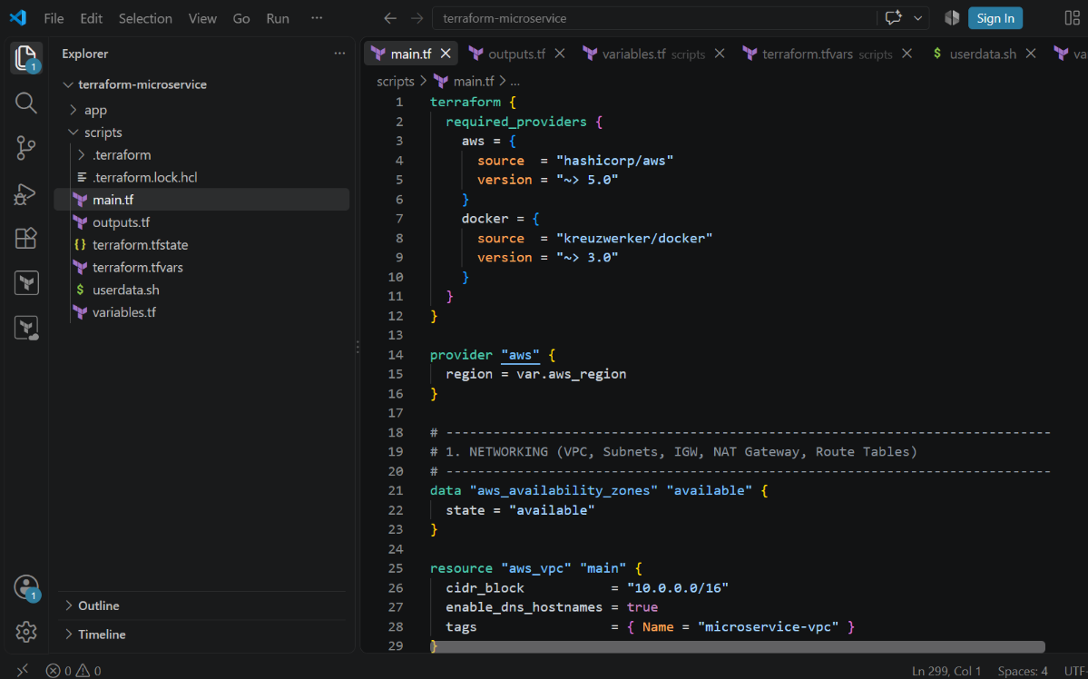

8. Configure Terraform Variables
Show your variables.tf.
Document these variables:
Variable | Purpose
aws_region | AWS deployment region
my_ip | IP allowed for SSH
public_key_path | Local SSH public key
Your terraform.tfvars contains the region, SSH allowed IP and public key path.

variables.tf
variable "aws_region" {
type = string
default = "us-east-1"
}

variable "my_ip" {
type = string
description = "Your local public IP address with CIDR block (e.g., '203.0.113.50/32') for SSH access."
}

variable "public_key_path" {
type = string
default = "~/.ssh/id_rsa.pub"
description = "Path to your local public SSH key."
}

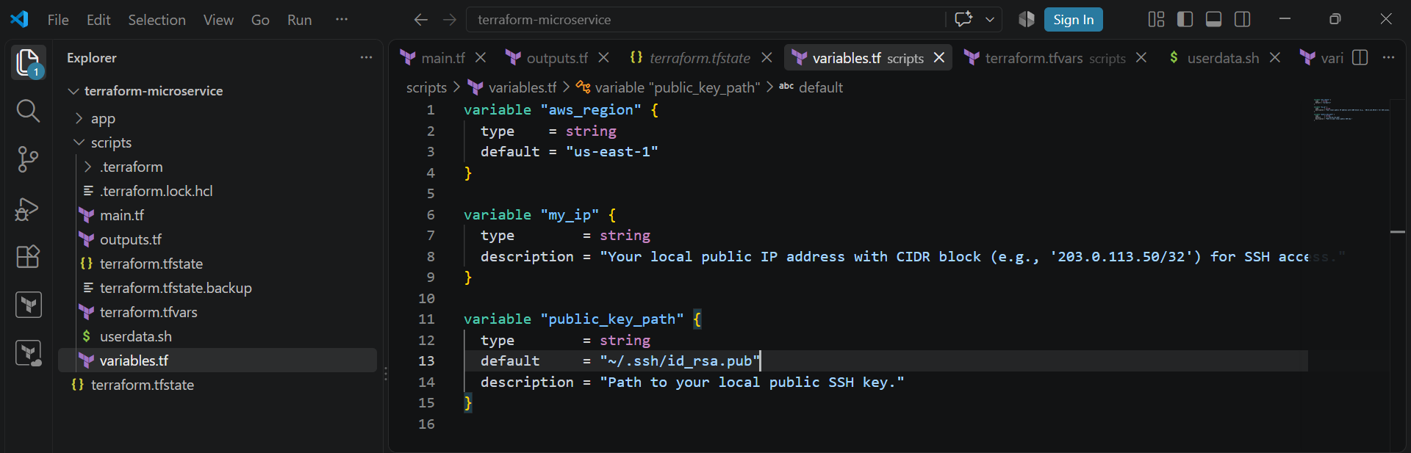

terraform.tfvars
aws_region = "us-east-1"
my_ip = "124.123.163.133/32" #change with your local machine ip not ec2 (VMs)
public_key_path = "~/.ssh/id_rsa.pub"
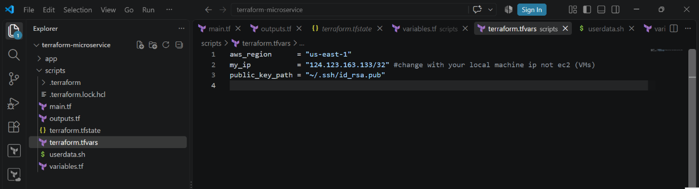
9. Initialize Terraform
Run:
terraform init
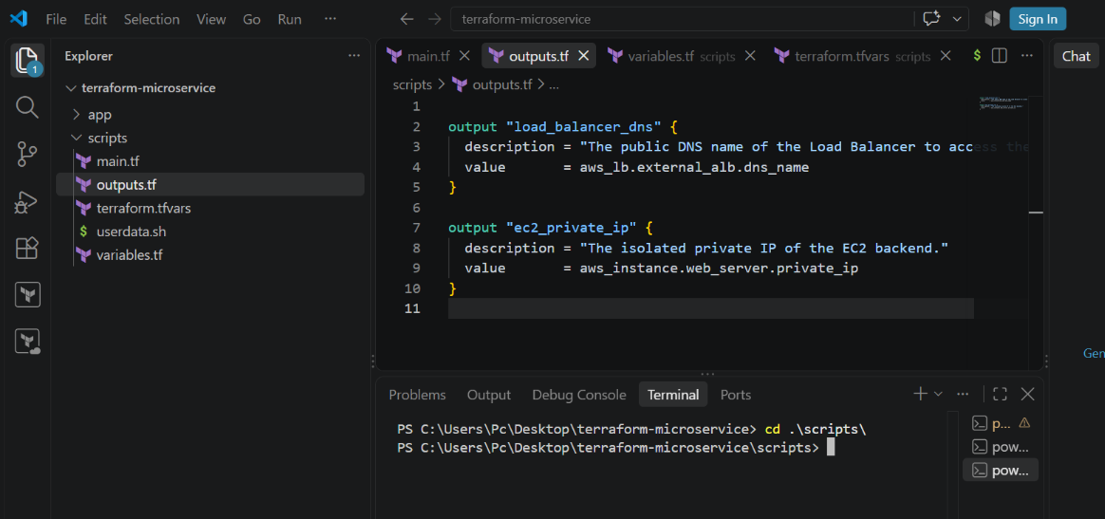
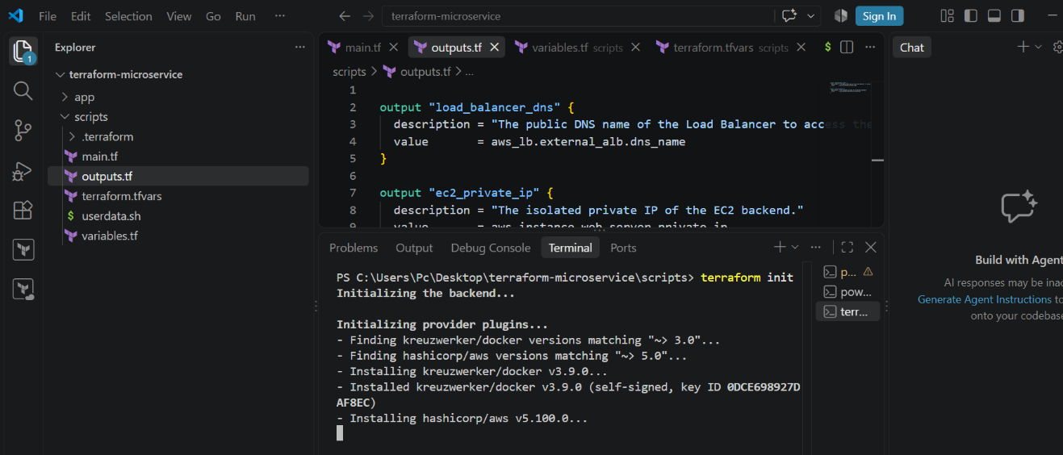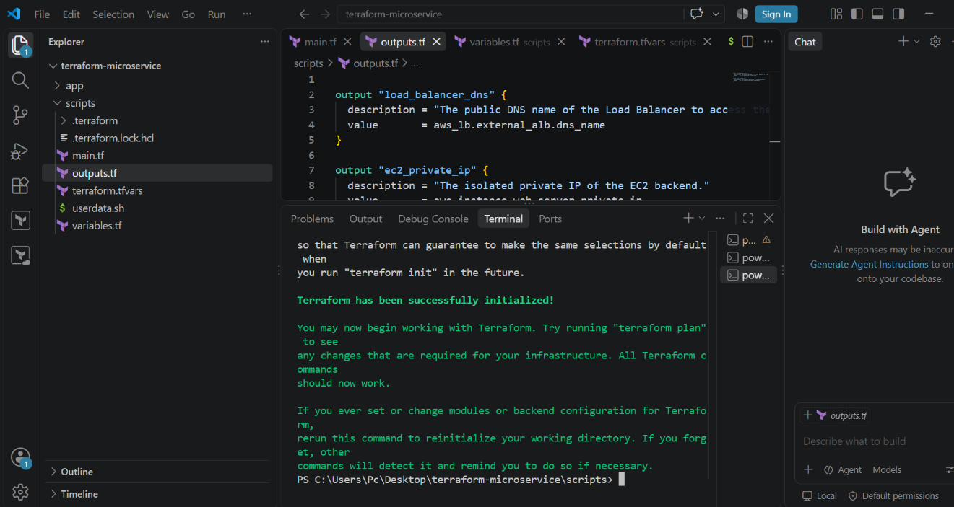

10. Validate Terraform Configuration
Run:
terraform validate
Expected result:
Success! The configuration is valid.
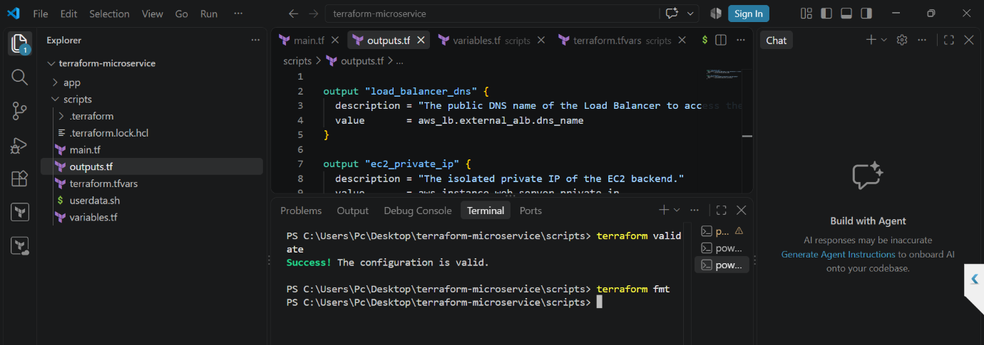

11. Create Terraform Plan
Run:
terraform apply
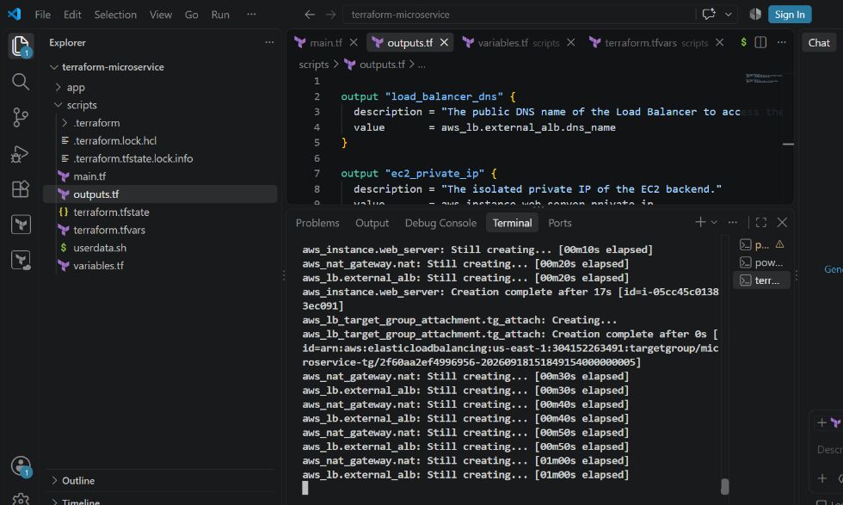
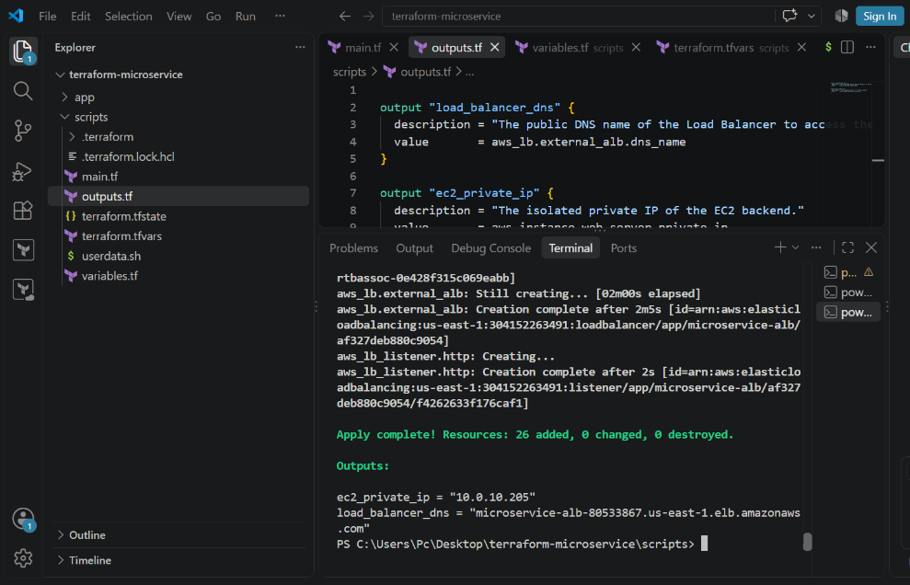

12. Build and Push Docker Image
Your Terraform configuration creates an Amazon ECR repository named:
microservice-app
and uses the Docker provider to build the local image and push it to ECR.
Document:
Local Docker Image
↓
Docker Provider
↓
Amazon ECR
↓
EC2
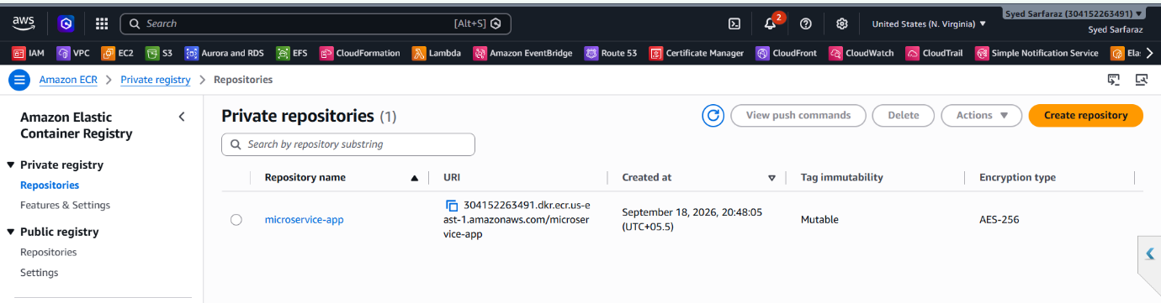
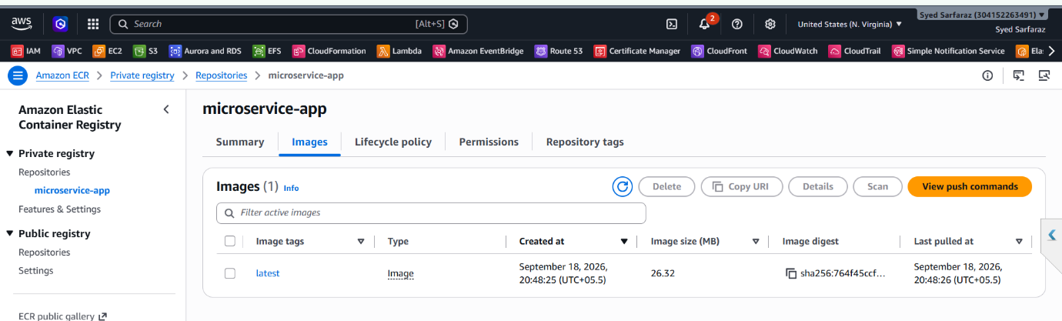

13. Deploy VPC and Networking
Explain the networking resources created by Terraform:
- VPC
- Internet Gateway
- 2 public subnets
- 1 private subnet
- NAT Gateway
- Elastic IP
- Public route table
- Private route table
- Route table associations
Your configuration places the ALB in the two public subnets and the EC2 instance in the private subnet.

Vpc
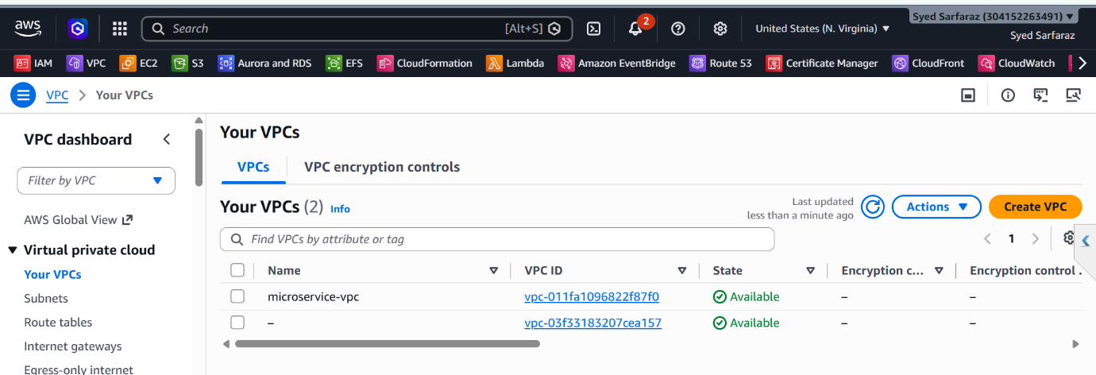
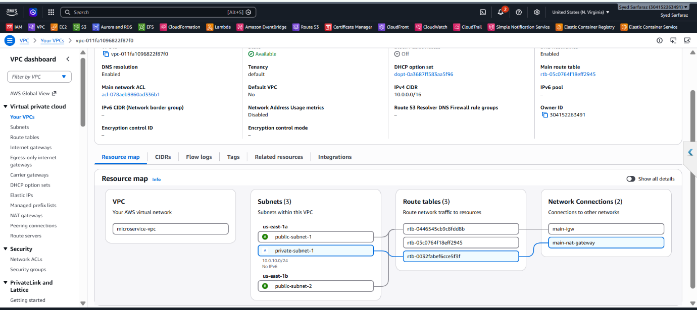

Subnet
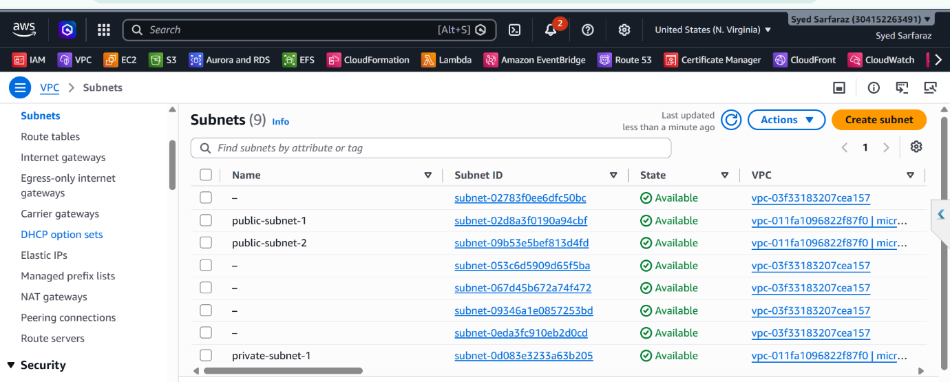
Elastic IP
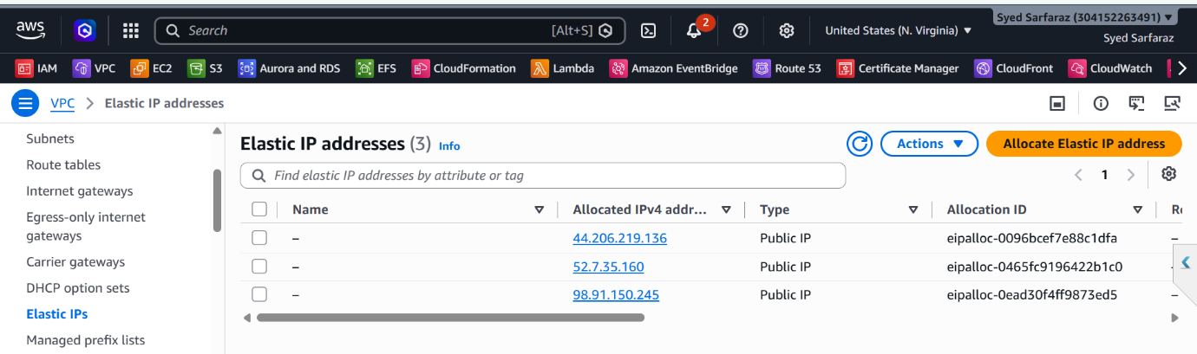
Key-Pair
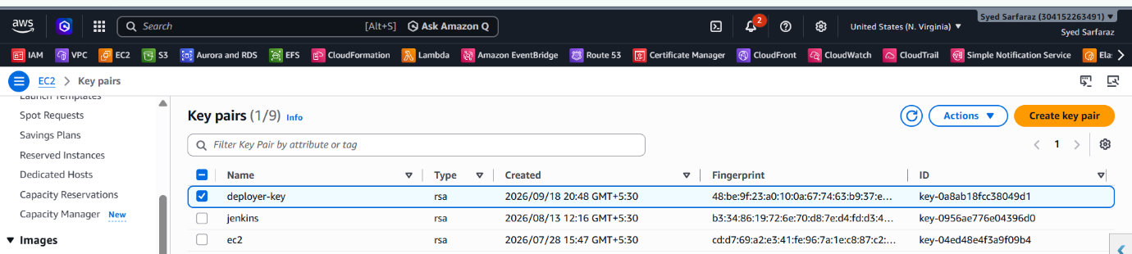

14. Configure Security Groups
Document the two security groups.
ALB Security Group
Allows:
HTTP : 80
Source: 0.0.0.0/0
EC2 Security Group
Allows:
HTTP : 80
Source: ALB Security Group
and:
SSH : 22
Source: Your configured IP
This ensures application HTTP traffic reaches the EC2 instance through the ALB, while SSH is restricted to the configured IP
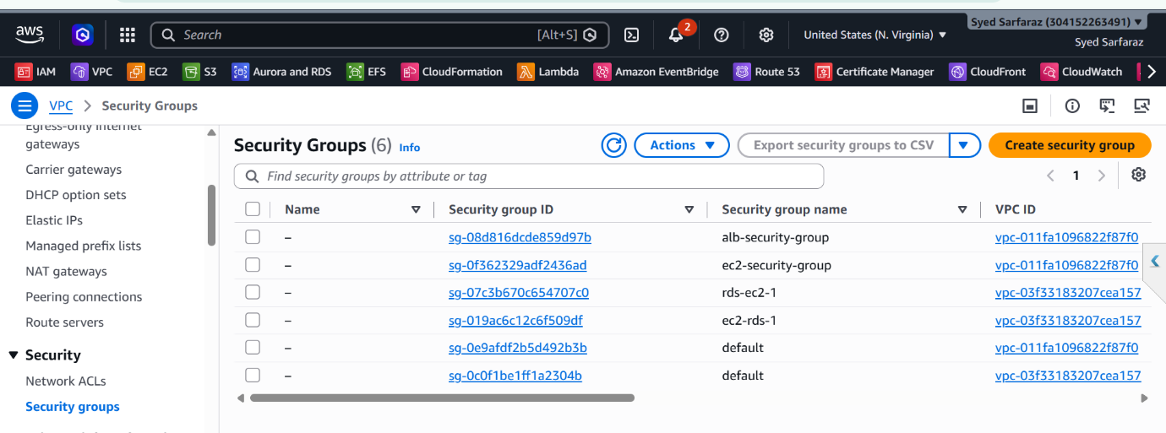

15. Create Application Load Balancer
Document:
- Application Load Balancer
- Internet-facing
- Port 80
- Public subnets
- Target group
- HTTP health check
- Listener
The ALB forwards HTTP traffic to the EC2 target group on port 80
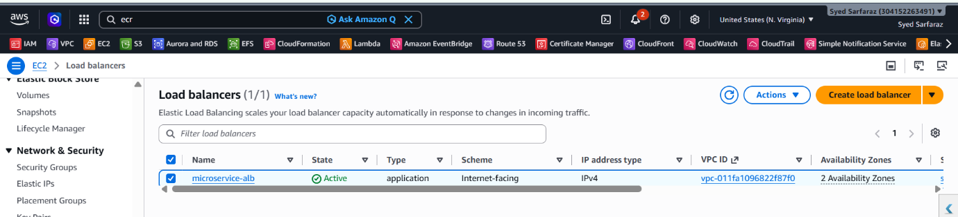
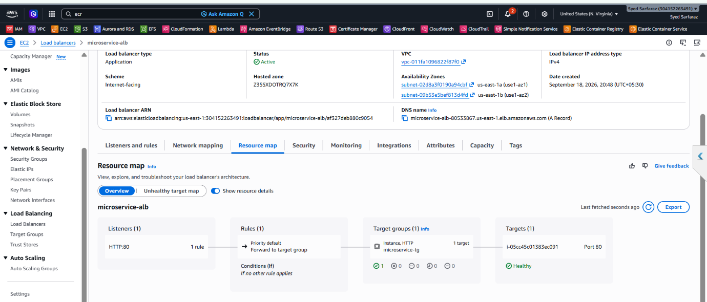
Target-Group
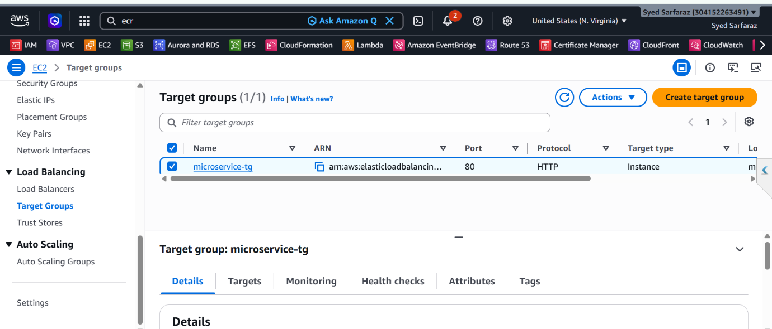

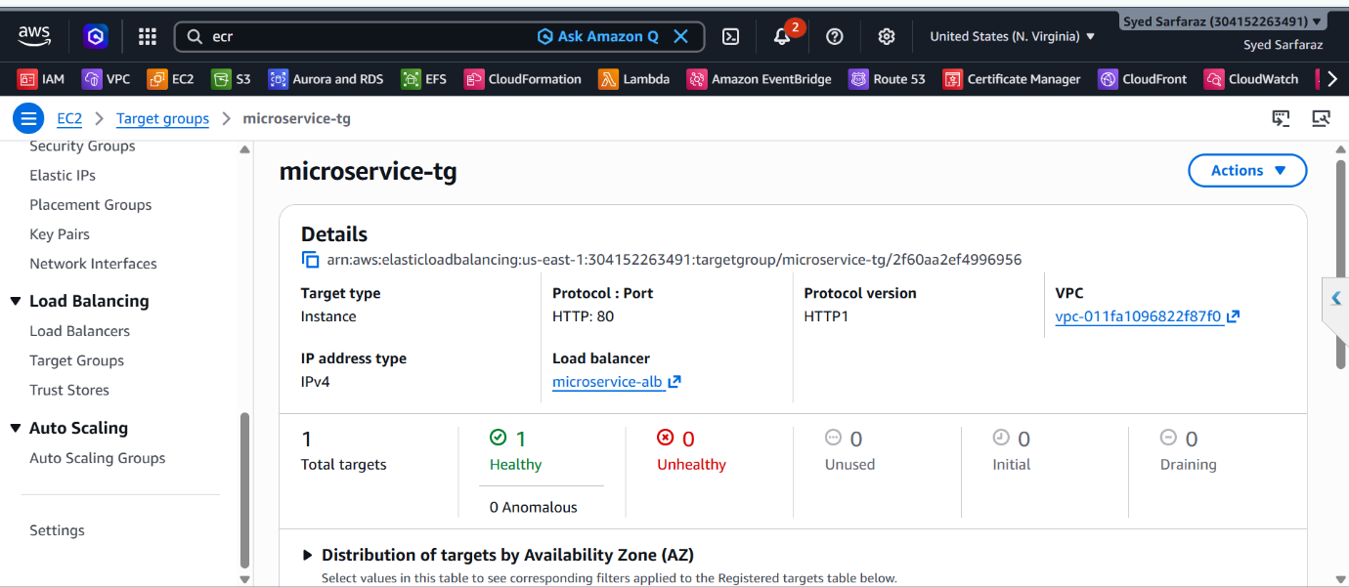
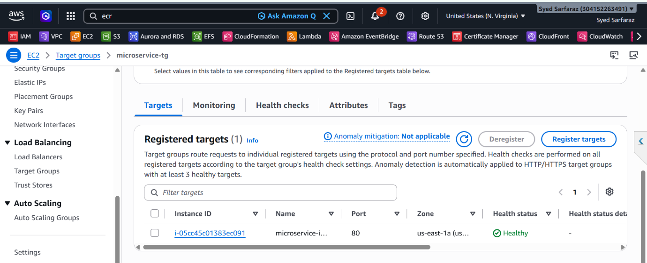

16. Create IAM Role for EC2
Explain that an IAM role is attached to EC2 so it can authenticate with Amazon ECR and pull the Docker image.
Your configuration attaches:
AmazonEC2ContainerRegistryReadOnly
to the EC2 role

17. Create EC2 Instance
Document:
- Amazon Linux 2023
- t3.micro
- Private subnet
- EC2 security group
- IAM instance profile
- SSH key pair
- No public IP
The instance is configured in the private subnet and receives the Docker deployment instructions through userdata.sh.
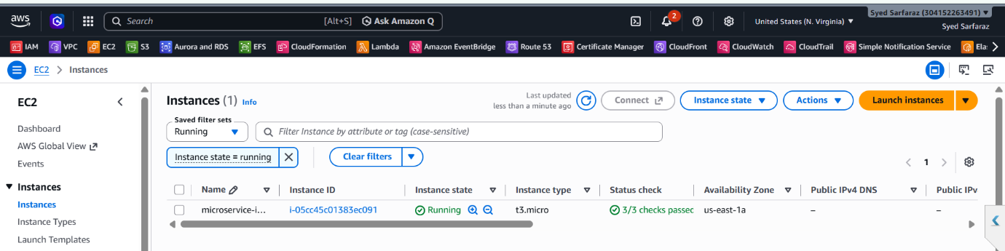

18. Deploy Docker Container Using User Data
Explain the deployment flow from userdata.sh:
EC2 starts
↓
Install Docker
↓
Start Docker
↓
Login to ECR
↓
Pull image from ECR
↓
Run Docker container
↓
Container listens on port 80
The user-data script installs Docker, authenticates to ECR, pulls the image, and runs the container on port 80

Userdata.sh
#!/bin/bash
LOG_FILE="/var/log/user_data.log"

echo "=== STARTING MICROSERVICE DEPLOYMENT ===" >> $LOG_FILE

# 1. Update and install Docker
echo "Installing Docker..." >> $LOG_FILE
dnf update -y >> $LOG_FILE 2>&1
dnf install -y docker >> $LOG_FILE 2>&1
systemctl start docker >> $LOG_FILE 2>&1
systemctl enable docker >> $LOG_FILE 2>&1

# 2. Extract ECR registry domain wrapper safely
REGISTRY_URL=$(echo "${repo_url}" | awk -F'/' '{print $1}')
echo "Registry domain target: $REGISTRY_URL" >> $LOG_FILE

# 3. Authenticate with AWS ECR
echo "Logging into AWS ECR..." >> $LOG_FILE
aws ecr get-login-password --region ${region} | docker login --username AWS --password-stdin $REGISTRY_URL >> $LOG_FILE 2>&1

# 4. Pull down the custom container image
echo "Pulling application image..." >> $LOG_FILE
docker pull ${repo_url}:${image_tag} >> $LOG_FILE 2>&1

# 5. Run the web server container on port 80
echo "Launching Nginx application..." >> $LOG_FILE
docker run -d -p 80:80 --name webapp --restart always ${repo_url}:${image_tag} >> $LOG_FILE 2>&1

echo "=== DEPLOYMENT COMPLETED SUCCESS ===" >> $LOG_FILE

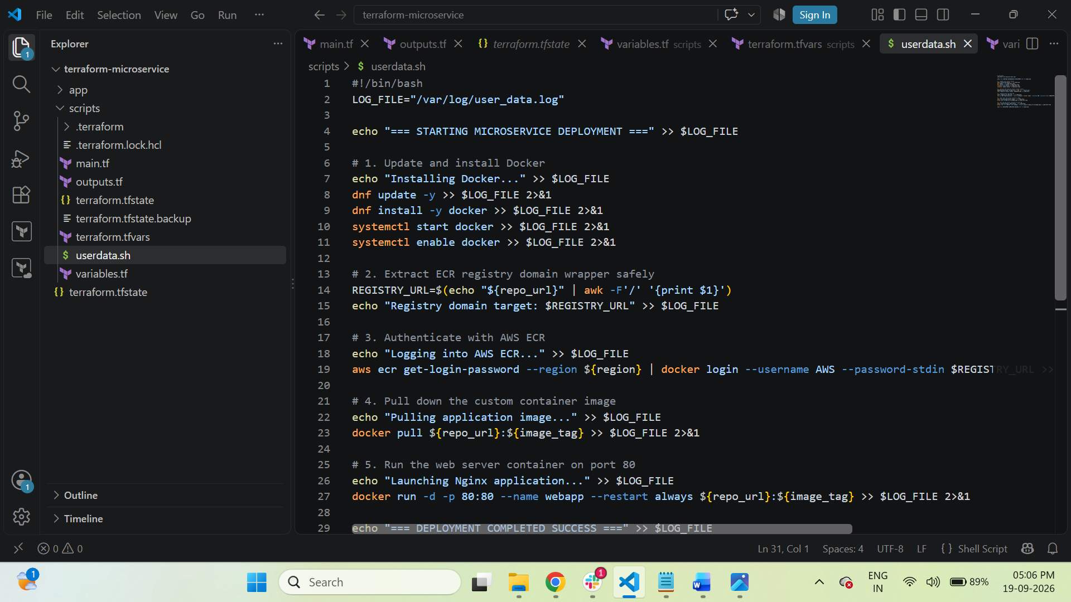

20. Verify Docker Container
SSH into the EC2 instance using your configured access method and verify:
docker ps
You should see:
webapp
Also verify:
docker images

21. Verify Application
Get the ALB DNS name:
terraform output load_balancer_dns
Open the ALB DNS name in your browser:
http://<ALB-DNS-NAME>
The static HTML page should be displayed.
Your Terraform output exposes the ALB DNS name for accessing the microservice.
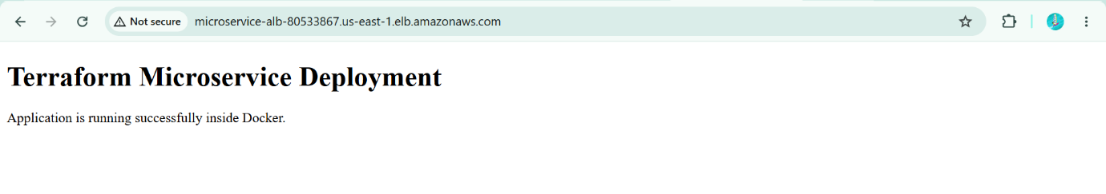

22. Verify Security
Document the expected traffic flow:
Internet
|
v
Application Load Balancer
|
| HTTP :80
v
Private EC2
|
v
Docker Container
SSH:
Your Allowed IP
|
| SSH :22
v
Private EC2

The application is not directly exposed through a public EC2 IP. HTTP access is allowed to the EC2 security group only from the ALB security group.

23. Terraform Outputs
Show:
terraform output
Expected outputs include:
load_balancer_dns
ec2_private_ip
These outputs are defined in outputs.tf

Output.tf

output "load_balancer_dns" {
description = "The public DNS name of the Load Balancer to access the microservice."
value = aws_lb.external_alb.dns_name
}

output "ec2_private_ip" {
description = "The isolated private IP of the EC2 backend."
value = aws_instance.web_server.private_ip
}

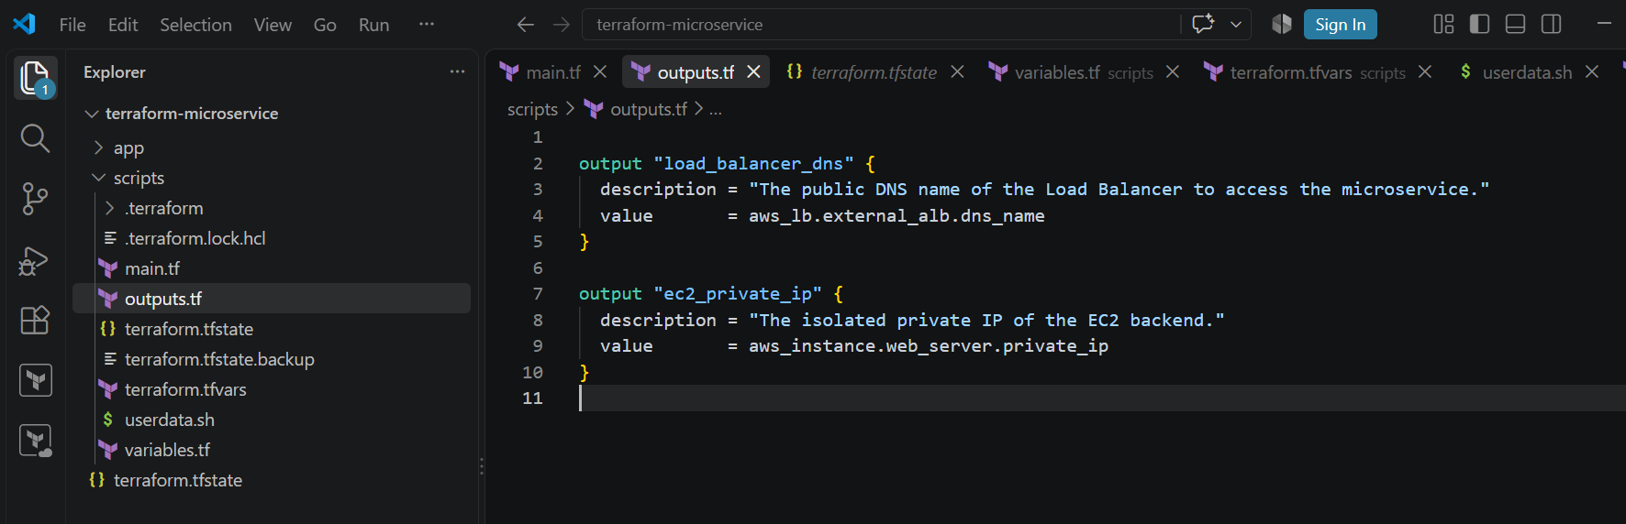

24. ECR repository
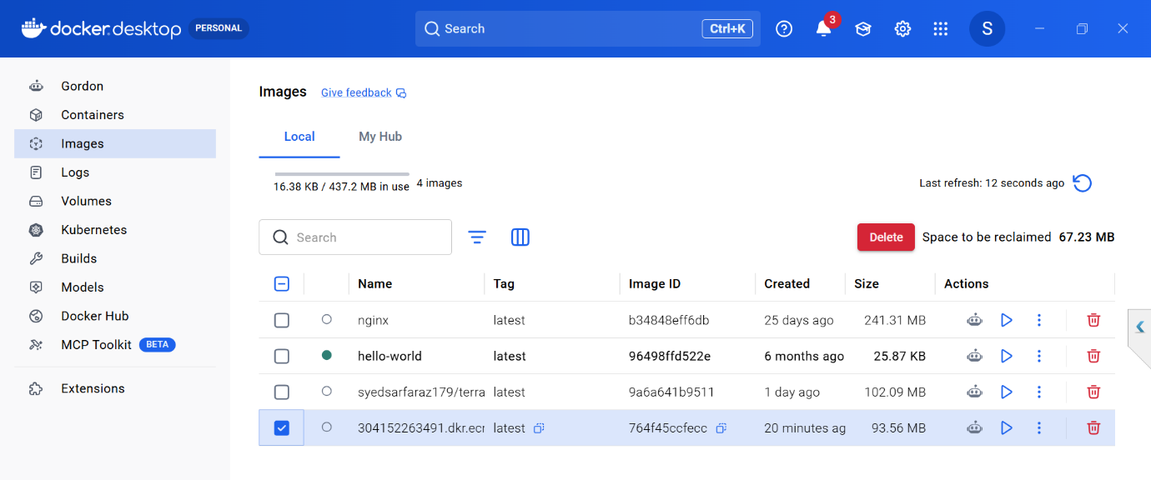
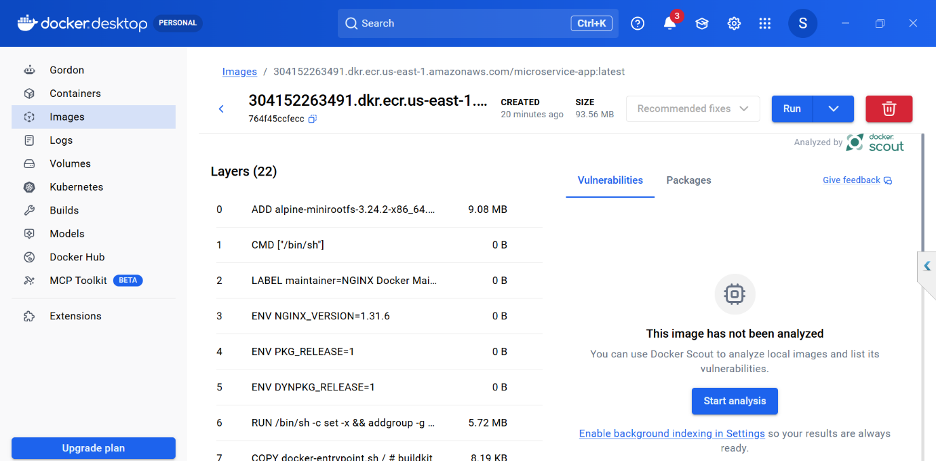

Full Script Of This Challenge

this is script for main.tf

terraform {
required_providers {
aws = {
source = "hashicorp/aws"
version = "~> 5.0"
}
docker = {
source = "kreuzwerker/docker"
version = "~> 3.0"
}
}
}

provider "aws" {
region = var.aws_region
}

# -----------------------------------------------------------------------------
# 1. NETWORKING (VPC, Subnets, IGW, NAT Gateway, Route Tables)
# -----------------------------------------------------------------------------
data "aws_availability_zones" "available" {
state = "available"
}

resource "aws_vpc" "main" {
cidr_block = "10.0.0.0/16"
enable_dns_hostnames = true
tags = { Name = "microservice-vpc" }
}

resource "aws_internet_gateway" "igw" {
vpc_id = aws_vpc.main.id
tags = { Name = "main-igw" }
}

# Public Subnets (for ALB)
resource "aws_subnet" "public_1" {
vpc_id = aws_vpc.main.id
cidr_block = "10.0.1.0/24"
availability_zone = data.aws_availability_zones.available.names[0]
tags = { Name = "public-subnet-1" }
}

resource "aws_subnet" "public_2" {
vpc_id = aws_vpc.main.id
cidr_block = "10.0.2.0/24"
availability_zone = data.aws_availability_zones.available.names[1]
tags = { Name = "public-subnet-2" }
}

# Private Subnet (for EC2)
resource "aws_subnet" "private_1" {
vpc_id = aws_vpc.main.id
cidr_block = "10.0.10.0/24"
availability_zone = data.aws_availability_zones.available.names[0]
tags = { Name = "private-subnet-1" }
}

# Elastic IP for NAT Gateway
resource "aws_eip" "nat" {
domain = "vpc"
depends_on = [aws_internet_gateway.igw]
}

# NAT Gateway to let private EC2 pull from ECR
resource "aws_nat_gateway" "nat" {
allocation_id = aws_eip.nat.id
subnet_id = aws_subnet.public_1.id
tags = { Name = "main-nat-gateway" }
}

# Routing
resource "aws_route_table" "public" {
vpc_id = aws_vpc.main.id
route {
cidr_block = "0.0.0.0/0"
gateway_id = aws_internet_gateway.igw.id
}
}

resource "aws_route_table" "private" {
vpc_id = aws_vpc.main.id
route {
cidr_block = "0.0.0.0/0"
nat_gateway_id = aws_nat_gateway.nat.id
}
}

resource "aws_route_table_association" "public_1" {
subnet_id = aws_subnet.public_1.id
route_table_id = aws_route_table.public.id
}

resource "aws_route_table_association" "public_2" {
subnet_id = aws_subnet.public_2.id
route_table_id = aws_route_table.public.id
}

resource "aws_route_table_association" "private_1" {
subnet_id = aws_subnet.private_1.id
route_table_id = aws_route_table.private.id
}

# -----------------------------------------------------------------------------
# 2. DOCKER REGISTRY (AWS ECR) & LOCAL IMAGE BUILD/PUSH
# -----------------------------------------------------------------------------
resource "aws_ecr_repository" "app_repo" {
name = "microservice-app"
image_tag_mutability = "MUTABLE"
force_delete = true
}

data "aws_ecr_authorization_token" "token" {}

provider "docker" {
registry_auth {
address = data.aws_ecr_authorization_token.token.proxy_endpoint
username = data.aws_ecr_authorization_token.token.user_name
password = data.aws_ecr_authorization_token.token.password
}
}

resource "docker_image" "local_build" {
name = "${aws_ecr_repository.app_repo.repository_url}:latest"
build {
# Points to the actual 'app/' folder relative to the 'scripts/' execution path
context = "${path.module}/../app" #In Your case it should be index.html page with dockerfile
dockerfile = "Dockerfile"
}
}

resource "docker_registry_image" "push_to_ecr" {
name = docker_image.local_build.name
keep_remotely = true
}

# -----------------------------------------------------------------------------
# 3. SECURITY GROUPS
# -----------------------------------------------------------------------------
resource "aws_security_group" "alb_sg" {
name = "alb-security-group"
vpc_id = aws_vpc.main.id
description = "Allow public HTTP traffic"

ingress {
from_port = 80
to_port = 80
protocol = "tcp"
cidr_blocks = ["0.0.0.0/0"]
}

egress {
from_port = 0
to_port = 0
protocol = "-1"
cidr_blocks = ["0.0.0.0/0"]
}
}

resource "aws_security_group" "ec2_sg" {
name = "ec2-security-group"
vpc_id = aws_vpc.main.id
description = "Isolate instance traffic"

# HTTP strictly from ALB
ingress {
from_port = 80
to_port = 80
protocol = "tcp"
security_groups = [aws_security_group.alb_sg.id]
}

# SSH strictly from your designated IP
ingress {
from_port = 22
to_port = 22
protocol = "tcp"
cidr_blocks = [var.my_ip]
}

egress {
from_port = 0
to_port = 0
protocol = "-1"
cidr_blocks = ["0.0.0.0/0"]
}
}

# -----------------------------------------------------------------------------
# 4. LOAD BALANCER (ALB)
# -----------------------------------------------------------------------------
resource "aws_lb" "external_alb" {
name = "microservice-alb"
internal = false
load_balancer_type = "application"
security_groups = [aws_security_group.alb_sg.id]
subnets = [aws_subnet.public_1.id, aws_subnet.public_2.id]
}

resource "aws_lb_target_group" "tg" {
name = "microservice-tg"
port = 80
protocol = "HTTP"
vpc_id = aws_vpc.main.id
target_type = "instance"

health_check {
path = "/"
port = "80"
protocol = "HTTP"
interval = 30
timeout = 5
healthy_threshold = 2
unhealthy_threshold = 2
}
}

resource "aws_lb_listener" "http" {
load_balancer_arn = aws_lb.external_alb.arn
port = "80"
protocol = "HTTP"

default_action {
type = "forward"
target_group_arn = aws_lb_target_group.tg.arn
}
}

# -----------------------------------------------------------------------------
# 5. EC2 INSTANCE & IAM ROLE FOR ECR
# -----------------------------------------------------------------------------
resource "aws_iam_role" "ec2_role" {
name = "ec2-ecr-reader-role"

assume_role_policy = jsonencode({
Version = "2012-10-17"
Statement = [{
Action = "sts:AssumeRole"
Effect = "Allow"
Principal = { Service = "ec2.amazonaws.com" }
}]
})
}

resource "aws_iam_role_policy_attachment" "ecr_read" {
role = aws_iam_role.ec2_role.name
policy_arn = "arn:aws:iam::aws:policy/AmazonEC2ContainerRegistryReadOnly"
}

resource "aws_iam_instance_profile" "ec2_profile" {
name = "ec2-ecr-profile"
role = aws_iam_role.ec2_role.name
}

resource "aws_key_pair" "deployer" {
key_name = "deployer-key"
public_key = file(var.public_key_path)
}

data "aws_ami" "amazon_linux_2023" {
most_recent = true
owners = ["amazon"]
filter {
name = "name"
values = ["al2023-ami-2023.*-x86_64"]
}
}

resource "aws_instance" "web_server" {
ami = data.aws_ami.amazon_linux_2023.id
instance_type = "t3.micro" # Free Tier eligible
subnet_id = aws_subnet.private_1.id
vpc_security_group_ids = [aws_security_group.ec2_sg.id]
key_name = aws_key_pair.deployer.key_name
iam_instance_profile = aws_iam_instance_profile.ec2_profile.id
associate_public_ip_address = false # Allows SSH access if you route directly or jump; code blocks outside traffic via SG

# Pass infrastructure context dynamically into user data
user_data = templatefile("${path.module}/userdata.sh", {
region = var.aws_region
repo_url = aws_ecr_repository.app_repo.repository_url
image_tag = "latest"
})

# Ensures instance pulls the image ONLY after the local computer successfully pushes it to ECR
depends_on = [docker_registry_image.push_to_ecr]

tags = { Name = "microservice-instance" }
}

resource "aws_lb_target_group_attachment" "tg_attach" {
target_group_arn = aws_lb_target_group.tg.arn
target_id = aws_instance.web_server.id
port = 80
}

This below script for outputs.tf

output "load_balancer_dns" {
description = "The public DNS name of the Load Balancer to access the microservice."
value = aws_lb.external_alb.dns_name
}

output "ec2_private_ip" {
description = "The isolated private IP of the EC2 backend."
value = aws_instance.web_server.private_ip
}

This below script for variables.tf

variable "aws_region" {
type = string
default = "us-east-1"
}

variable "my_ip" {
type = string
description = "Your local public IP address with CIDR block (e.g., '203.0.113.50/32') for SSH access."
}

variable "public_key_path" {
type = string
default = "~/.ssh/id_rsa.pub"
description = "Path to your local public SSH key."
}

This below script for terraform.tfvars

aws_region = "us-east-1"
my_ip = "117.206.242.192/32" #change with your local machine ip not ec2 (VMs)
public_key_path = "~/.ssh/id_rsa.pub"

This below script for userdata.sh

#!/bin/bash
LOG_FILE="/var/log/user_data.log"

echo "=== STARTING MICROSERVICE DEPLOYMENT ===" >> $LOG_FILE

# 1. Update and install Docker
echo "Installing Docker..." >> $LOG_FILE
dnf update -y >> $LOG_FILE 2>&1
dnf install -y docker >> $LOG_FILE 2>&1
systemctl start docker >> $LOG_FILE 2>&1
systemctl enable docker >> $LOG_FILE 2>&1

# 2. Extract ECR registry domain wrapper safely
REGISTRY_URL=$(echo "${repo_url}" | awk -F'/' '{print $1}')
echo "Registry domain target: $REGISTRY_URL" >> $LOG_FILE

# 3. Authenticate with AWS ECR
echo "Logging into AWS ECR..." >> $LOG_FILE
aws ecr get-login-password --region ${region} | docker login --username AWS --password-stdin $REGISTRY_URL >> $LOG_FILE 2>&1

# 4. Pull down the custom container image
echo "Pulling application image..." >> $LOG_FILE
docker pull ${repo_url}:${image_tag} >> $LOG_FILE 2>&1

# 5. Run the web server container on port 80
echo "Launching Nginx application..." >> $LOG_FILE
docker run -d -p 80:80 --name webapp --restart always ${repo_url}:${image_tag} >> $LOG_FILE 2>&1

echo "=== DEPLOYMENT COMPLETED SUCCESS ===" >> $LOG_FILE

